**CS551 Advanced Software Engineering**

**Lab 1**

**Due: Aug. 28 (W)**

**Name :** Gireshbabu Yemparala | **ID No:** 16137268

Task 1: Create a ScrumDo account, perform the tasks shown in Tutorial 1

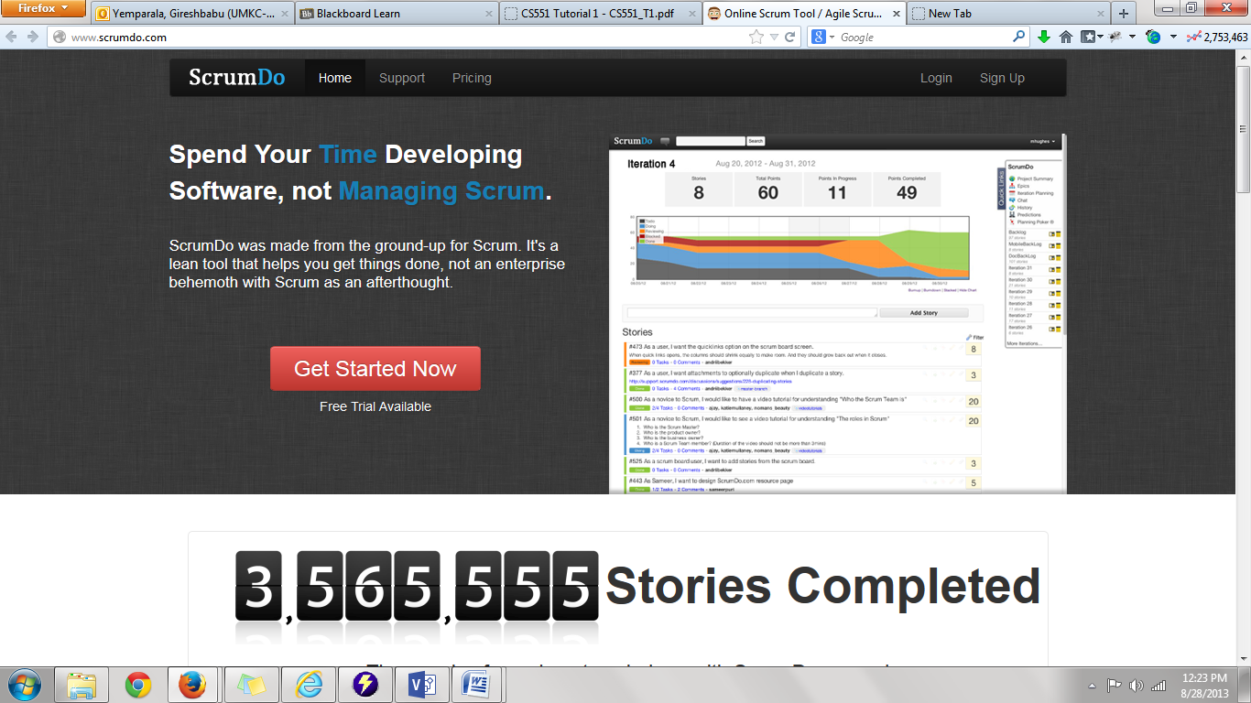Go to the webpage <http://www.scrumdo.com/> and click on the “signup”

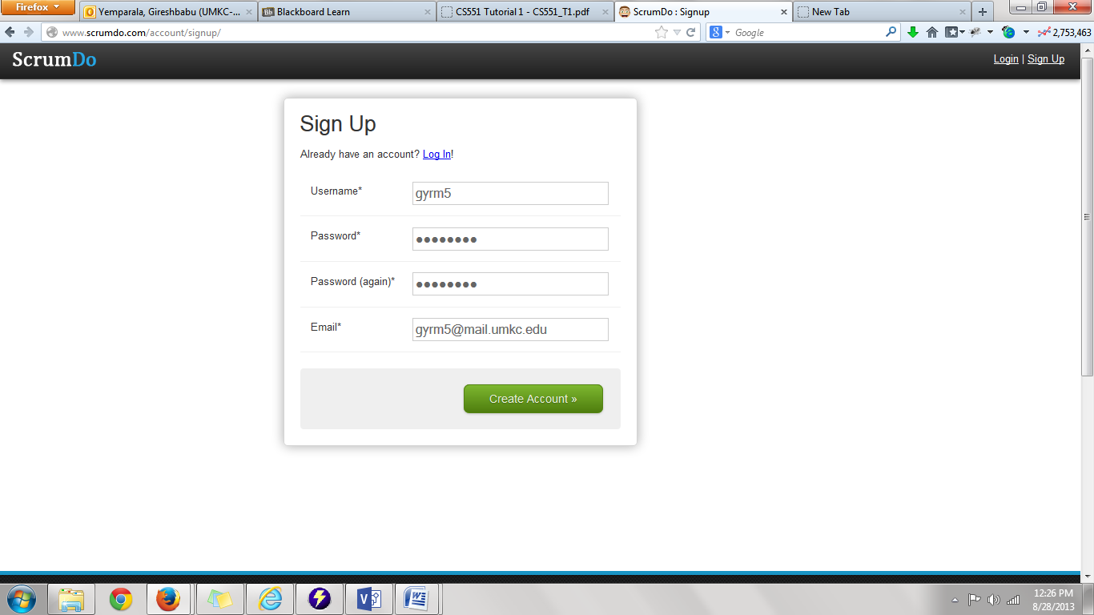Complete the login details in the signup page and hit “ create account”

Then fill in the details of the project members and the project title and the name of the organization and then hit “next “

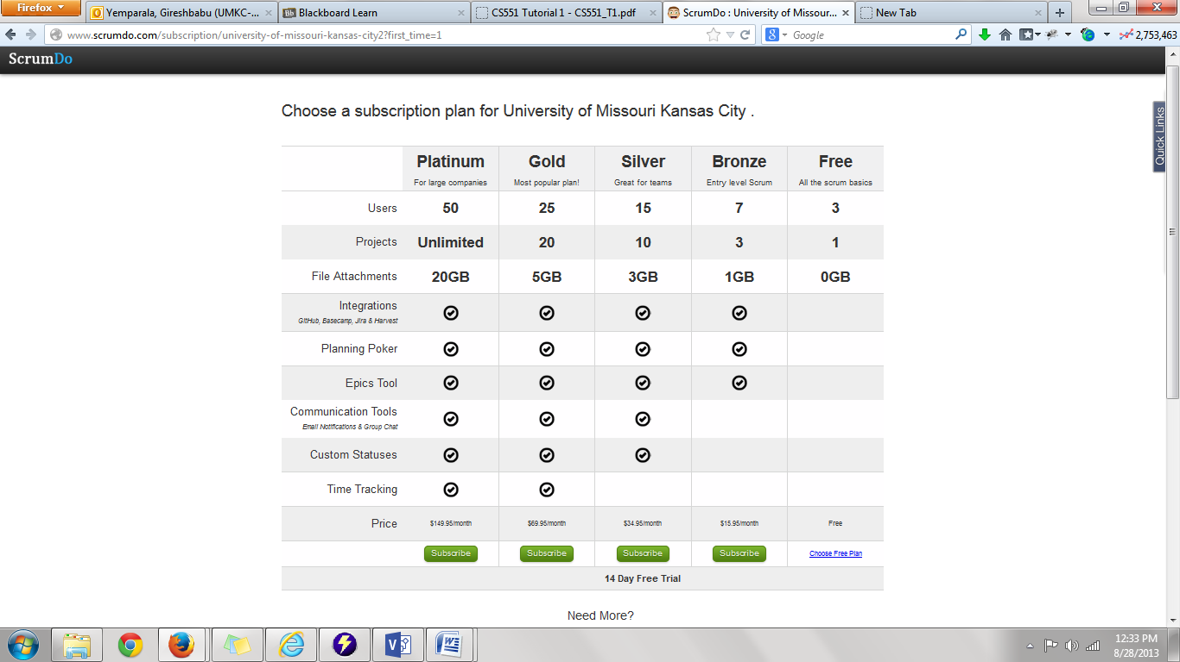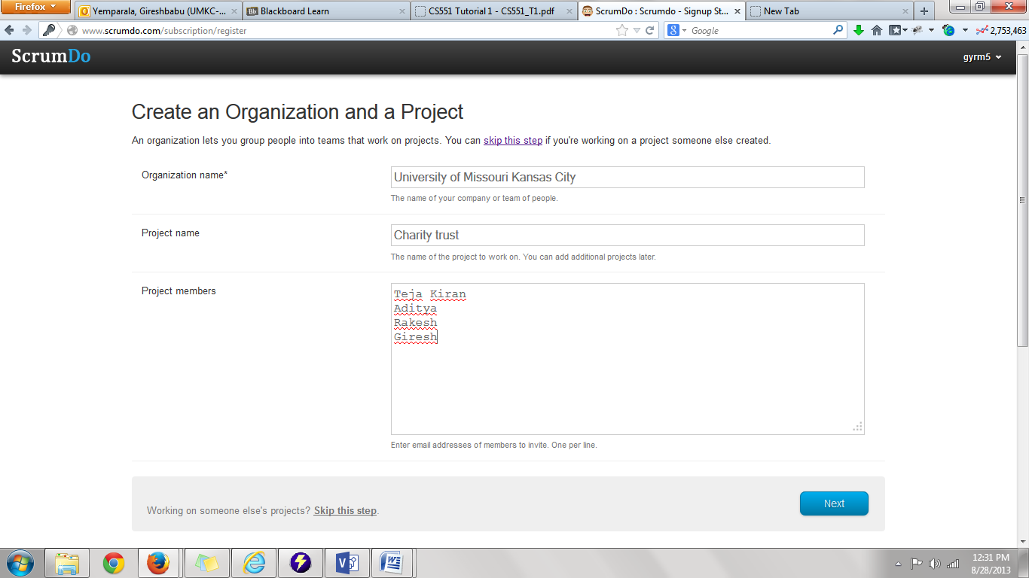then choose a plan that suits your company needs ie I would go with free plan

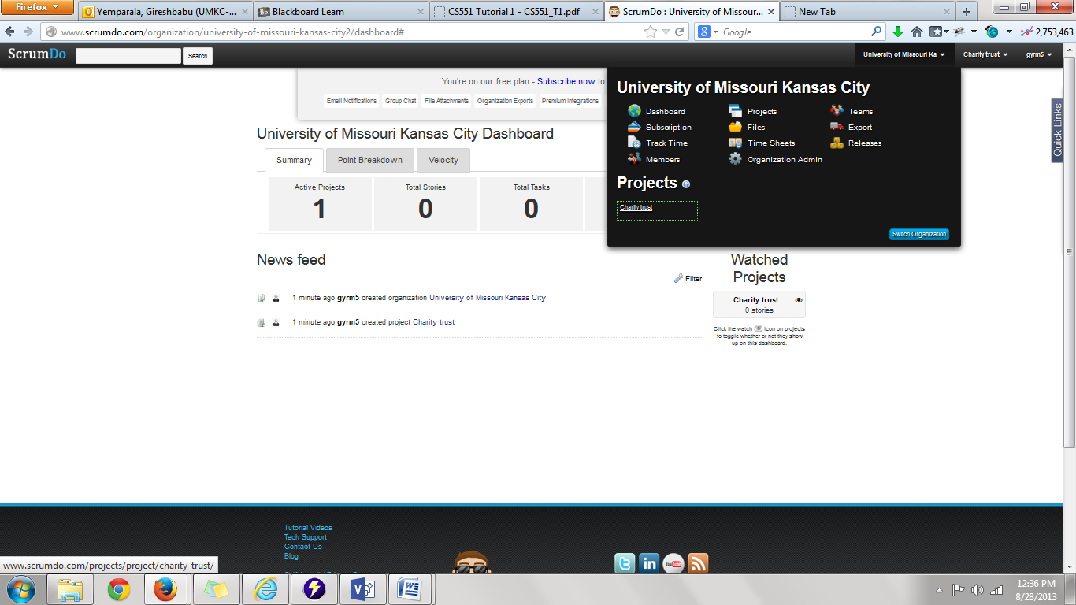now create a story

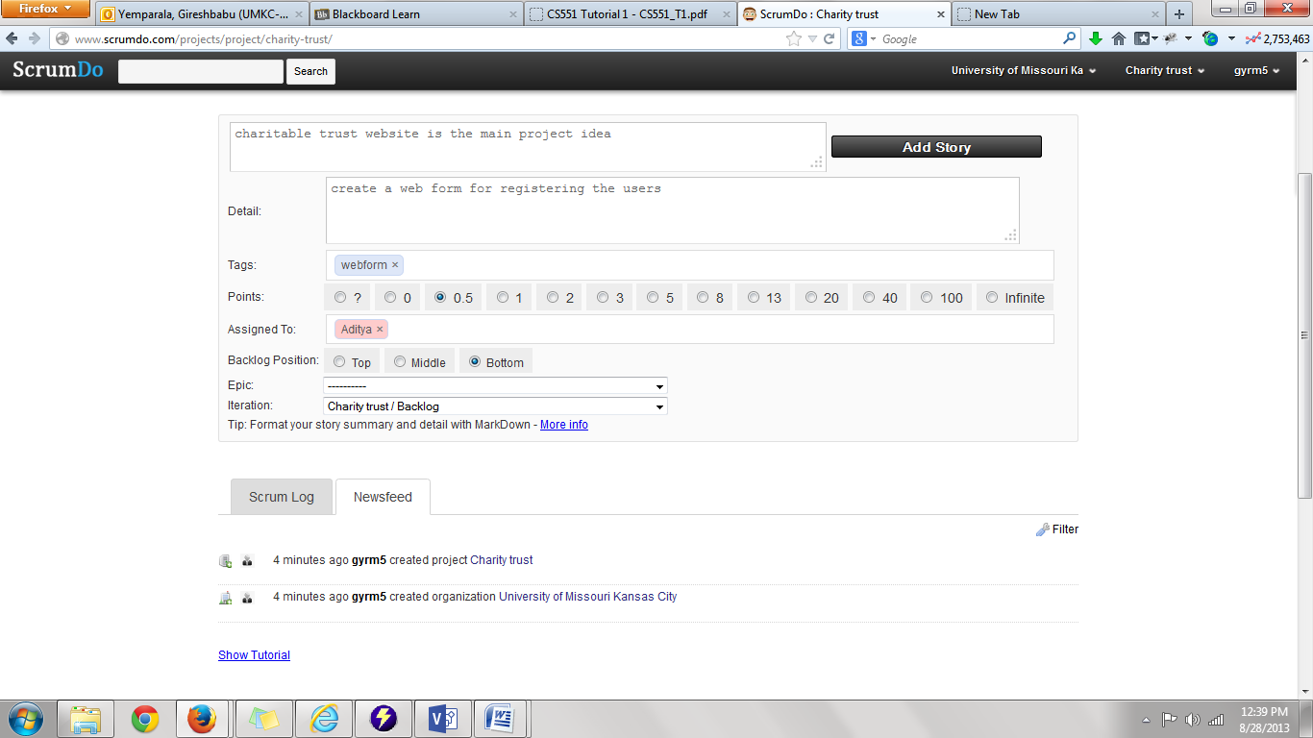then hit “add story”

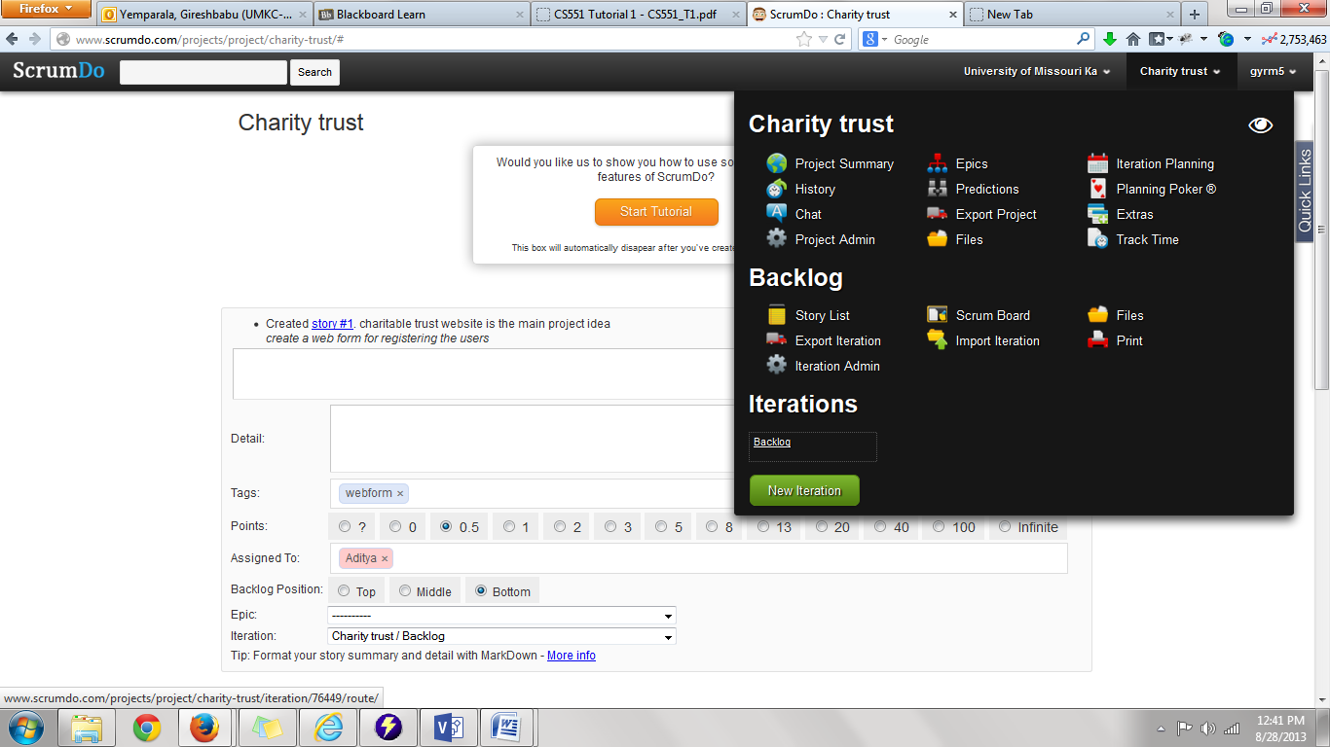then go to the project tab and click on the “backlog” under “Iterations “

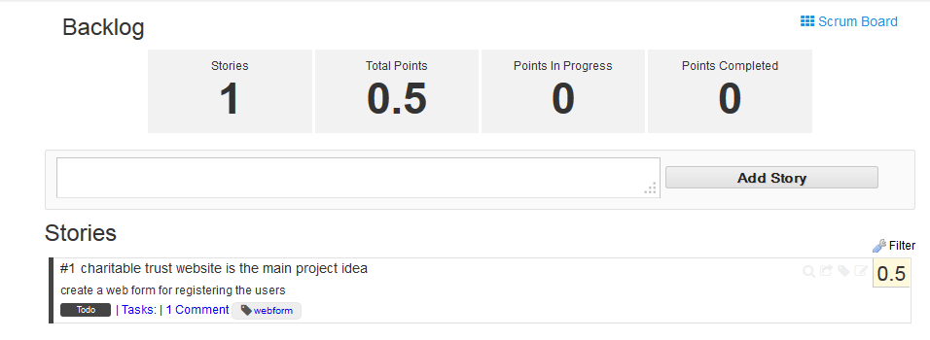

Creating a new Iteration

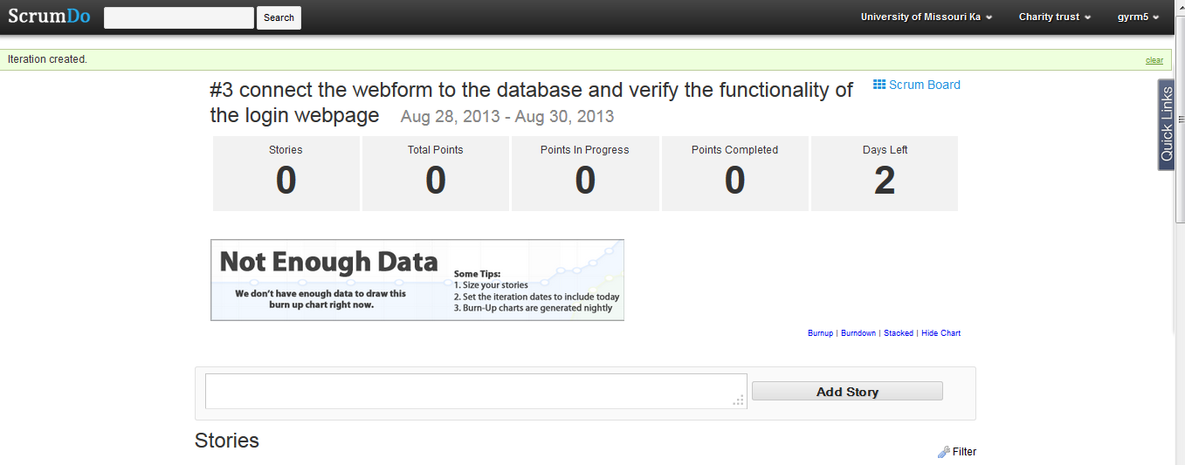

Iteration planning

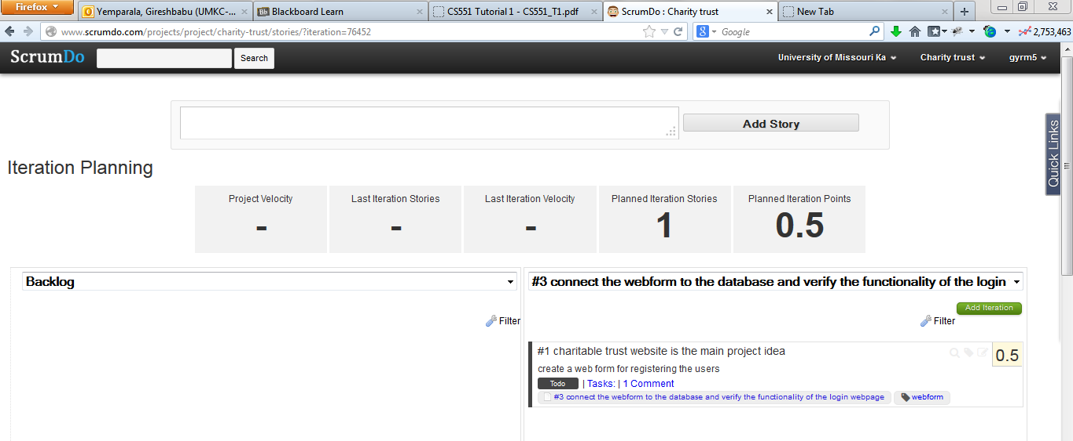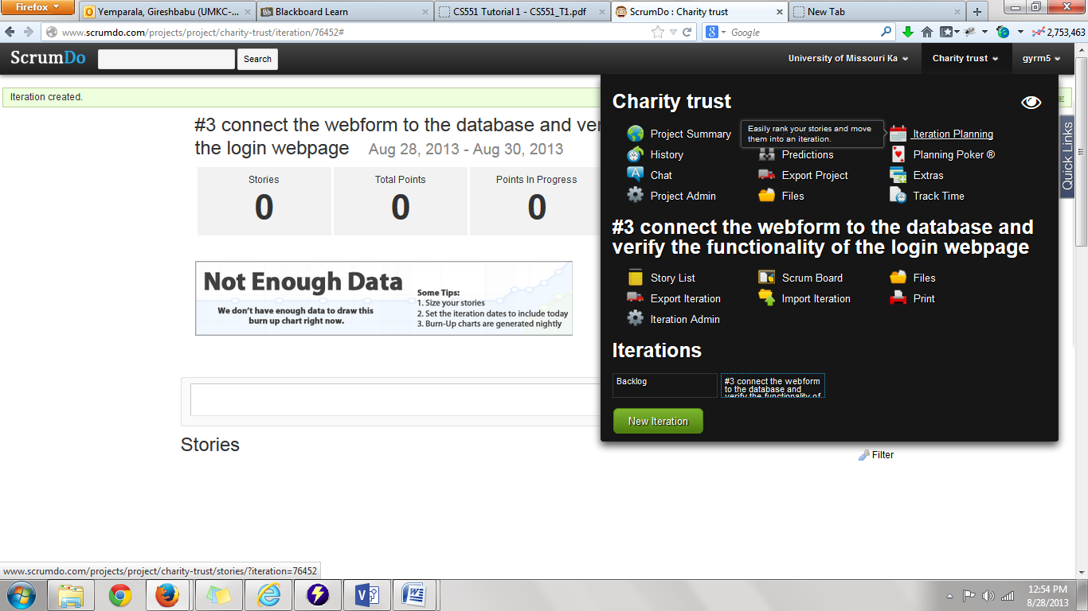

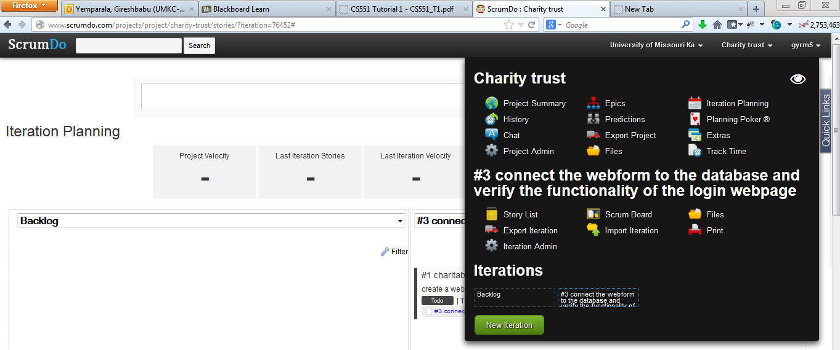create an epic story

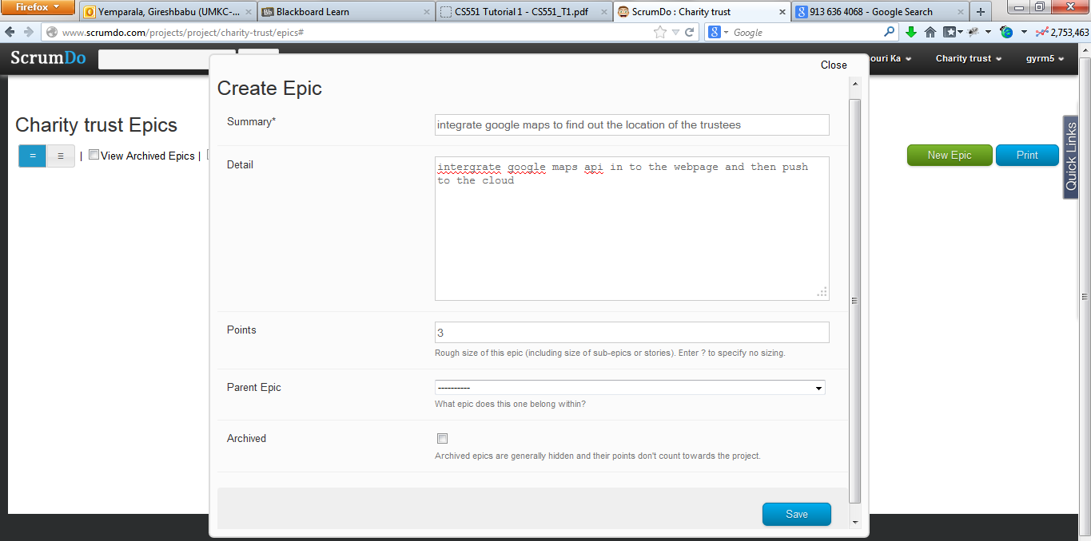

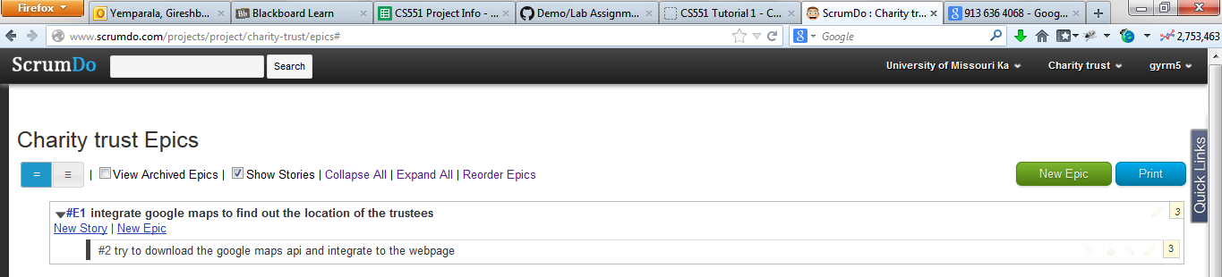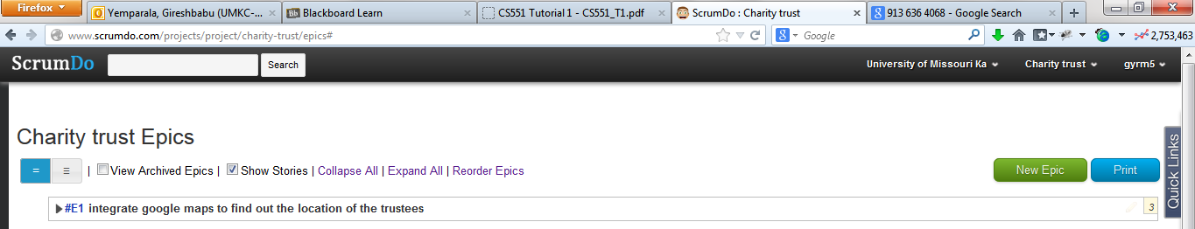

now go to the scrum board

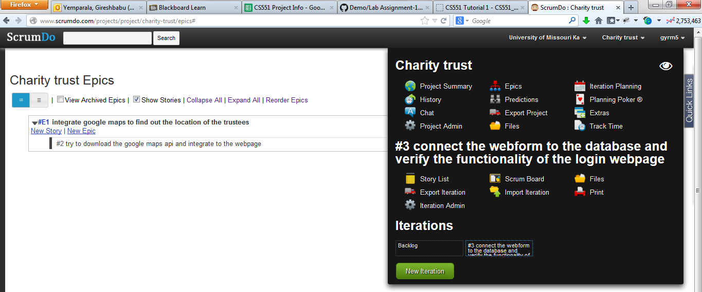

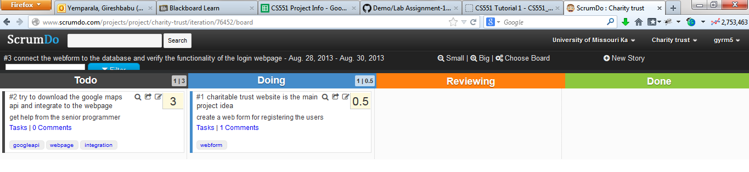

Add and contact the teams by choosing the teams option in the dashboard

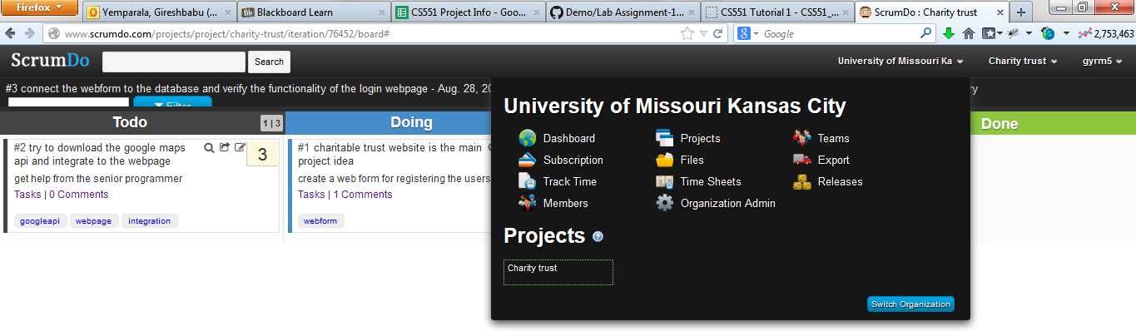

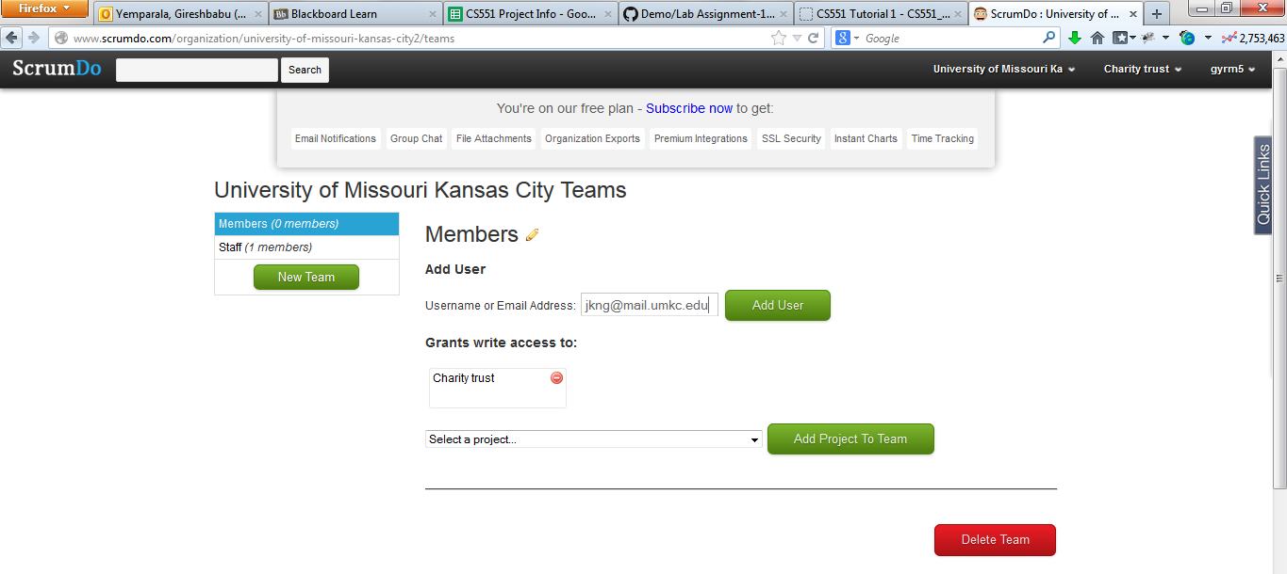Add new teams and team members to the project

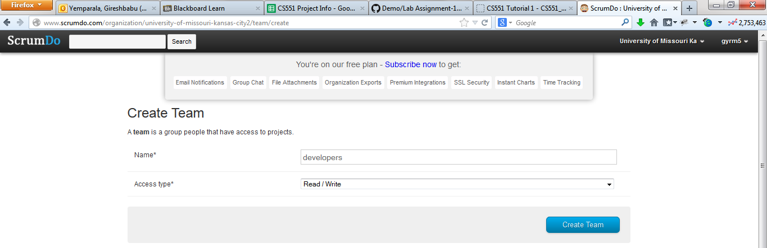this sends a mail to the team members mail address by which they can join to the project

Task 2: Create a GitHub account, perform the tasks shown in Tutorial 1

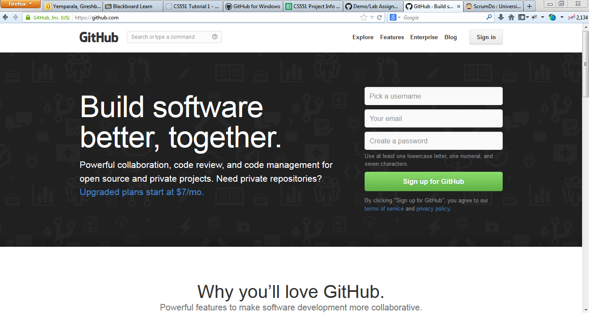Go to <http://github.com>

Create a repository

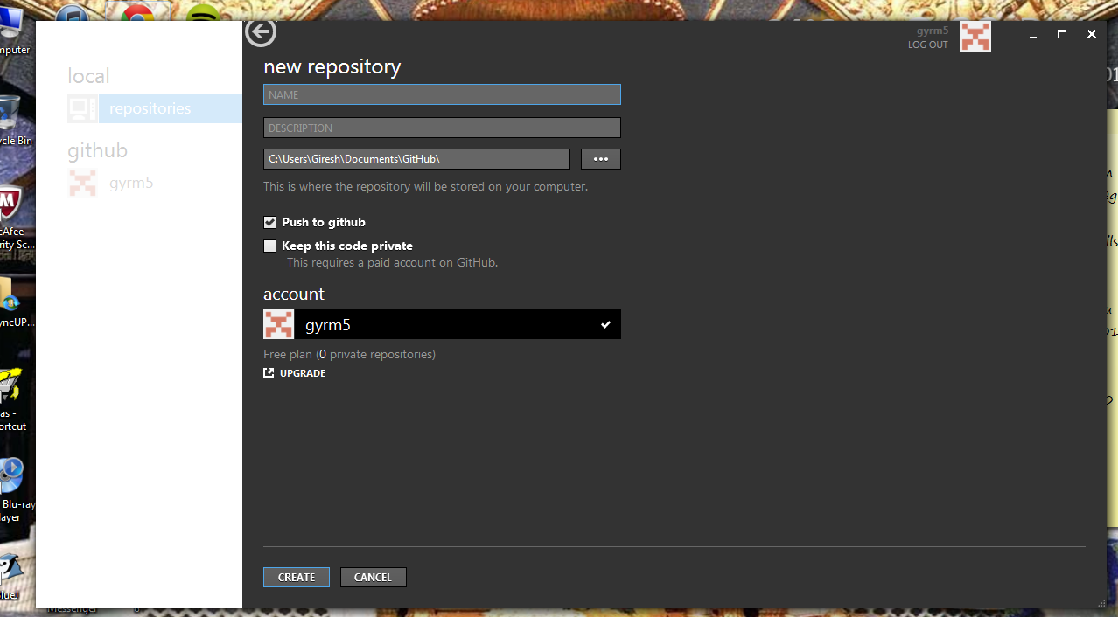

New repository repos is created

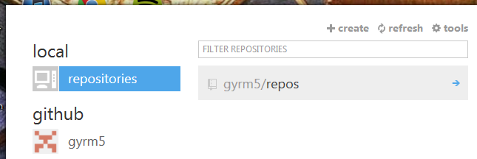

Create a clone of the repo

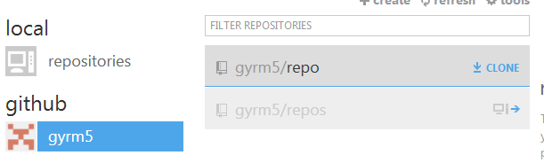

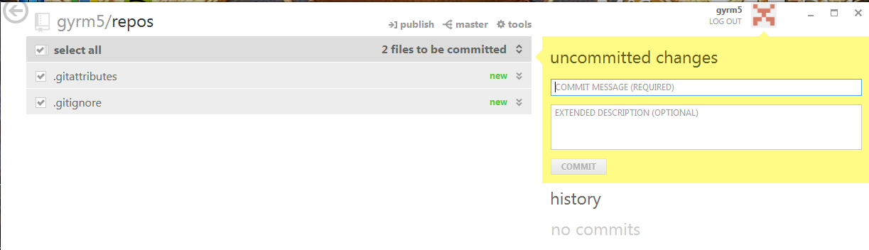Open the repository

Check the email address

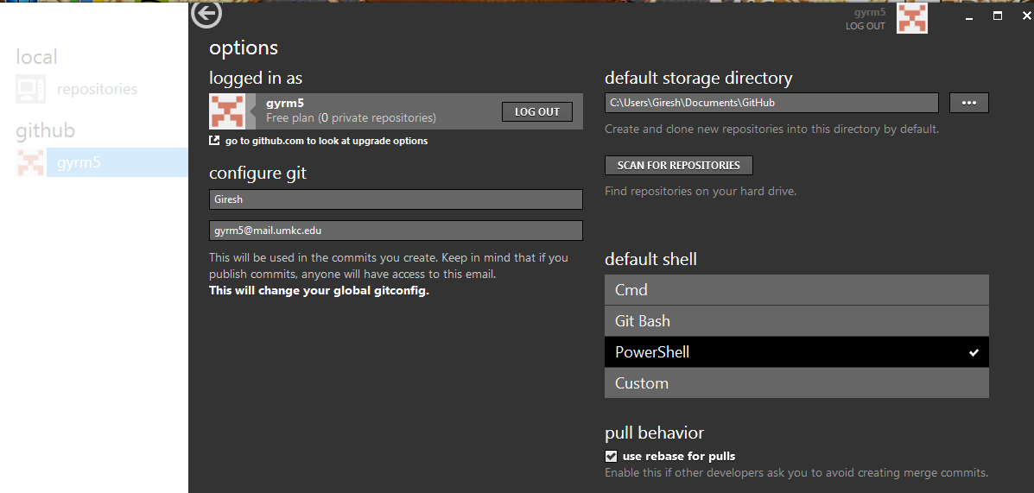

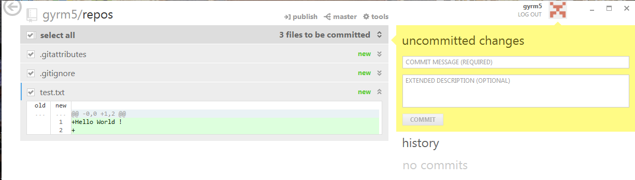Check the uncommitted changes dialog popup

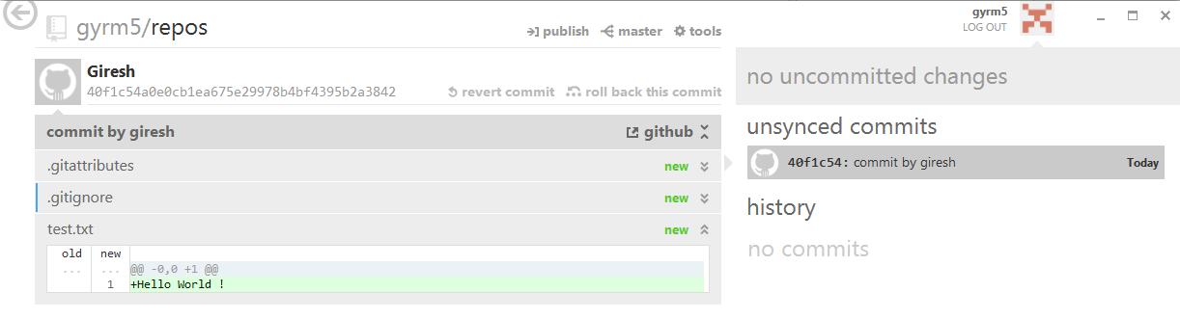enter commit message and press commit

click publish to sync

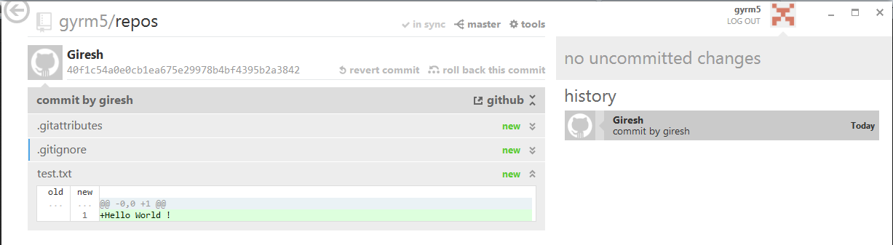

Check the commit in the remote

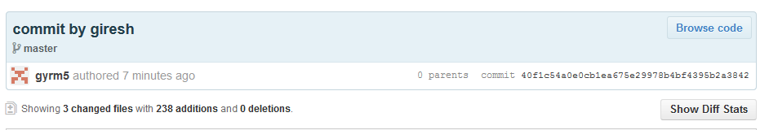

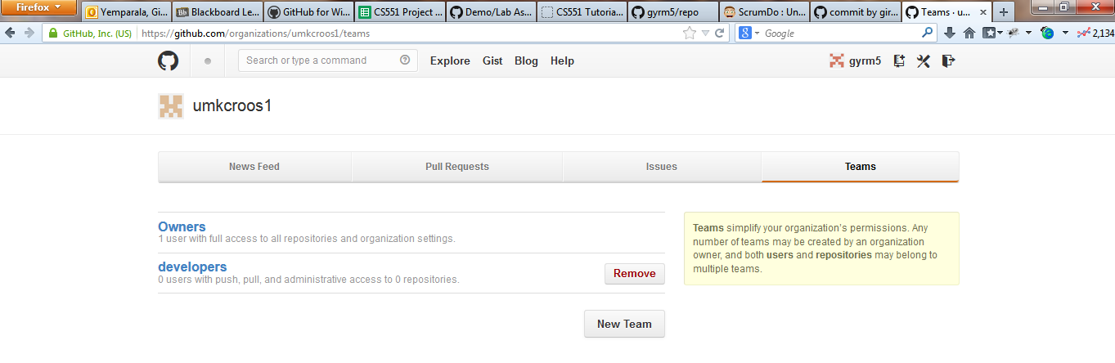Add team member

